# Lancer Rocker Recliner

Description $1699

The phrase "the best seat in the house" must have been invented for this Lancer rocker recliner! Pillow arms and a plush backrest are just the tip of the iceberg when it comes to this piece's best assets. It also features 18 reclining positions and a chaise-style footrest that takes all the pressure off your legs. Plus, the handsome charcoal chenille fabric is incredibly versatile, fitting in easily with a range of colors and decor.

Product Details

Dimensions (in)

W: 38" x D: 39" x H: 42"

Color

Charcoal

Style

Transitional

Reclining Features

Manual Reclining

Weight Capacity

300

Fabric

Polyester Blend

Pattern

Solid

Materials

Hardwood, Kiln Dried Wood, MDF Board

Finish

Mahogany

Joinery

Mortise and Tenon, Corner Block, Double Dowel, Glue

Cushion Type

Polyester Wrapped Cushion

Fill Material

Foam

Core Density

1.8

Seating Support

Sinuous Coil Spring System

Spring Gauge

8.00

Seating Type

Reclining, Rocking

Seat Cushion Style

Attached

Arm Style

Padded/Pillowed

Back Style

Attached Pillow Back

Seat Depth

20.50

Seat Height

19.00

Care

Lightly brush or vacuum frequently to remove dust and grime. Spot clean with water- or solvent-based cleaners. Pre-test cleaning methods on a hidden surface. A professional cleaning service is recommended for an overall soiled condition.

Additional Features

Reclining, Removable Back

Vendor

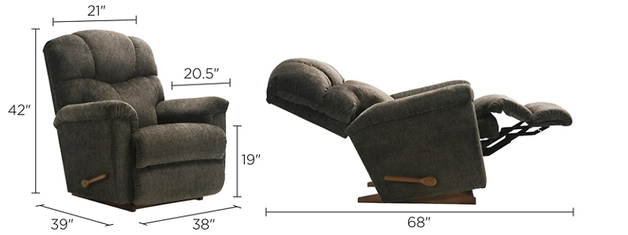La-Z-Boy Recliner